Models of Perception and Action - Exam

Jakub Raszka ([201806223@post.au.dk](mailto:201806223@post.au.dk))

Models of Perception and Action

School of Communication and Cognition, University of Aarhus,

Jens Chr. Skous Vej 2, 8000 Aarhus, Denmark

Aarhus, 9.6. 2020

## Perception and Action

A traditional view which information-processing theory holds that perception and action could be treated as separate processes seems to be outdated, within the light of new behavioural and neuronal evidence. As Massaro (1990) aptly put it, consider a classical view on cognition as a sandwich consisting of three levels: perception, cognition and action, where perception and action can interact only indirectly through cognition. In reality, they are largely inter-connected to one another as formulated in common coding theory (Prinz, 1997) and further developed in the *event coding theory* (Hommel et al., 2001). The theories propose that the same brain region associated with perception and are active during action likewise (Halász & Cunnington, 2012). Neuronal evidence favouring the theories over alternatives, comes from special neurons that are active both at observing and performing a task. They are called mirror neurons and their discovery kindled a wave of excitement within the scientific community and the general public.

An intricate study carried out by Aglioti et al. (2008) investigated among other things the motor excitability of a part dedicated to the arm muscles among three groups: elite basketball players, professional basketball journalists, and control subjects who were not familiar with the basketball whatsoever. Every group was presented with two video, either a basketball player who is about to make a free shot, or a football player who is about to initiate a kick. Watching the former video increased the activity in the motor cortex.

Another study, Butler & James (2013) conducted an fMRI study wherein 15 subjects were supposed to learn audio-visuo-motor associations. The objects which were taught were accompanied with sounds, simulating the multisensory integration which appears at “natural” learning when. Crucially, there were two conditions: active and passive learning. Every participant learnt half of the stimuli in active learning condition, the other one in passive. The former means that participant was asked to execute motor movement to bolster the learning effect, while the passive learning consists of watching an experimenter executing the motor movement, action.

Interestingly enough, in the active learning condition, the subjects learnt the stimuli faster, compared to passive learning. The effect also sustained over a delay when participants got out of the fMRI scanner and were tested for the retention rate and the objects learned in the active way were faster recognized and at higher rate. But what is crucial for the argument is that in the regions of motor, somatosensory areas, and cerebellum, a larger activation was detected at stimuli learnt actively. Areas traditionally associated with action, motor execution and coordination enhanced the perception and the ability to recognize the stimuli. Interestingly, this effect was not present if only one sensory information, either visual or auditory, was provided. Lastly, the functional connectivity was increased between visual and motor areas.

One of the pivotal evidence for the action-perception link is the employment of motor action region at mere observation of the specific action. Therefore, the action and perception has to be closely connected, if not identical, as Hommel suggested (2019). “Perception is something you do, not something that happens to you.” As Bridgeman & Tseng nicely put it (2011, p.1). Moreover, the activation can lead to enhanced learning and the question distinction of perception and action might be useful only for textbooks.

## Mouse-tracking

Using mouse-tracking as a method for data collection is very efficient, inexpensive and primarily highly informative method. Similar facts could be give also for the well-established button-press paradigm. However, when we compare them, there is one distinction which favours the former. Namely, mouse tracking can reflect subtle changes in one’s behaviour which are represented, for instance, by the mouse trajectory. One could argue that a similar, if not the same piece of information, is encoded in the reaction time of a button-press design. Indeed, it is, although in less informative form, let’s deliberately overlook it. Consider a following experiment. A participant is instructed to choose his/her favourite colours from 5 distinct colours over several trial with varying sets of colours. Employment of the button-press method would reliably inform us about the most favourite colour. The reaction time could be interpreted as an indicator of one’s confidence in a given choice. In other words, the slower reaction time, the less decisive and certain a participant is.

However, to answer question which colour cause some trial to be slower is much more difficult to answer. That is where the fine-grained property of mouse-tracking excels. As the mouse movement executed with our hands are found to be “ a valid index of evolving decisions” (Freeman, 2018, p.1), based on the trajectory, one can infer what is the “disturbing” colour which causes the prolonged reaction time. Therefore, the mouse-tracking is more suitable for studying and distinguishing in-between states/decisions.

Eye movements are driven by attention and are said to be a window to one’s mind and has been fruitfully employed in various domains, such as behavioural economy, human-computer interaction or cognitive psychology. Both methods treats brain processes as continuous, constantly unfolding, rather than merely tabulating the outcome into several discrete stages (Spivey, 2007) which is a step forward. In terms of precision, the eye-tracking has the upper hand (Oyekoya & Stentiford, 2005). On the other hand, nowadays, almost every household in the developed world is equipped with a computer and a mouse, thus the potential sample size for mouse-tracking is by several magnitudes larger and the invested resources smaller, thus making it a great candidate for a big-data study.

So far it has been vaguely discussed what variables we can measure. They could be divided into 4 basic categories based on what aspects are measured: curvature, complexity, time, and derivatives (Kieslich et al., 2018). Let’s have an example of classical experimental design to have get better understanding of what measures and when are useful. We have ben working on a development of a new package for a plant-based yogurt. Several attractive options were built but only one can be implemented. To put it into a test, a survey is made where respondents are ask the choose the package they are the most likely to buy.

The experiment is usually conducted in the full screen window with mouse starting at the bottom and the options being at the top screen. Factors such as mouse sensitivity, equal distance of all products to the mouse initiation, and click or mouse-over option selection, handedness, randomization, etc. must be taken into consideration (Kieslich et al., 2018). If we want to go beyond the simple count of how many times every option was taken, we can investigate the maximum absolute deviation (MAD). It means that an ideal line from the beginning to every option is drawn and comparted to the curvature. Then the MAD is the longest difference between actual and ideal curvature. However, plotting raw or smoothed heatmaps is more robust alternative.

To uncover and further quantify competing options, one can measure complexity. In a two-option design, if we imagine a line in between the options, the number one flips the line is a good indicator of competitiveness. In more complex design, entropy, total time or distance can be more informative. Given the design outlined, a heatmap along with entropy or time elapsed, total distance travelled would be a useful measures to indicate whether respondents were in doubts when choosing the best-selling package for plant-based yogurt. The potential of mouse-tracking either in scientific field or commercial one is great and so are the risks and problems with data privacy, especially in the latter.

## Interacting with objects

When a person reaches for a bottle, a fairly simple movement is underpinned by a great deal of processes which take into consideration many factors. One of the underlying mechanisms are internal models of the motor system which enable us to simulate an action of our body as well as the reaction to the action. In other words, the models have an essential role when comes to predicting one’s movements. It is generally agreed that there are two sets of models – forward and backward, also called inverse, models. The inverse models inform a person about what motor commands are essential to realize the desire movement. They aim to predict what movements are needed based on the sensory feedback. While forward modelling has the opposite function – it aims to describe the sensory consequences based on the motor commands. If the prediction does not respond to one’s intention, forward models enable to adjust the motor commands accordingly even before movement initiation. To fully appreciate smoothness and rapid flexibility of our internal models, one can ask engineers how difficult it is to code a robot to precisely execute a movement, let alone to improvise in an unknown terrain (Hommel et al., 2016).

The internal models are employed whenever we interact with the environment. But what difference does destination of a bottle make in terms of the models? When one wants to put a bottle on a higher shelf, compared to a lower shelf, one has to grip the bottle in its lower part to makes sure that he/she can reach all the way up the shelf. Also, a person has to consider bottle’s weight more seriously as the higher we reach, the more difficult it is. While, if one aims to place a bottle on a lower shelf, the more balanced grip would be somewhere in the middle. Also, the weight is no longer crucial, although it still remains important. These factors and many other will impact the prediction of backward modelling what specific movements are in need, how much tension in our forearm muscle is needed. Whether a person must straighten up and stand on toes to reach the upper shelf, or the current the round-shouldered posture is good enough to place a bottle on the lower shelf.

While the forward modelling inform a person how the motor command will and whether it is appropriate given the bottle’s shape, size, weight, surface adhesion and whether the motor commonads should be adjust or are appropriate given the action goal. The models are constantly running, evaluating before during and even after the movement initiation.

## Option A

Per&Act-Exam

JR

9 6 2020

## Data loading

## loading txt data  
data1 <- read_delim(file = "105_1.txt", delim = ",", col_names = FALSE)

## Parsed with column specification:  
## cols(  
## X1 = col_double(),  
## X2 = col_double(),  
## X3 = col_double()  
## )

data2 <- read_delim(file = "105_2.txt", delim = ",", col_names = FALSE)

## Parsed with column specification:  
## cols(  
## X1 = col_double(),  
## X2 = col_double(),  
## X3 = col_double()  
## )

## renaming columns  
data1 <- data1 %>%   
 rename(time = X1, y = X2, z = X3)  
  
data2 <- data2 %>%   
 rename(time = X1, y = X2, z = X3)

## Data plotting

# as the data frames are of different lengths, the cannot be combined and must be plotted in diffrent geoms  
ggplot(data1, aes(time, y)) +   
 geom_point(color = "pink") +  
 geom_point(data = data2, aes(time,y), color = "blue") +  
 labs(title = "Visualization of Y coordinate in time of the two trajectories",  
 subtitle = "Pink = first trajectory Blue = second trajectory",  
 x = "Time",  
 y = "Y coordinate")

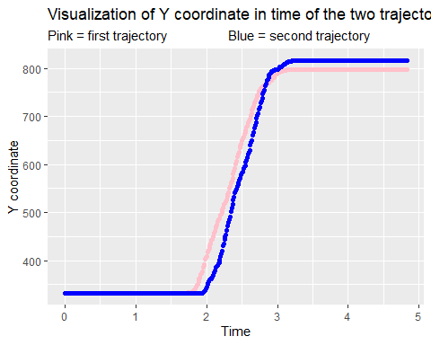

## Velocity, filter

## Z velocity  
  
data1$z_vel <- c(0, diff(data1$z) / diff(data1$time))  
  
# the velocity for every data point is calculated with distance from the previous to current Y cordinate, divided by the time taken to execute the movement  
  
# because is the difference between two data points, the first value will alaways miss a value to be compared to, therefore we manually insert a 0 to account for this and have a column of the same length  
  
## plotting Z velocity against time  
ggplot(data1, aes(time, z_vel)) +   
 geom_point(color = "pink") +  
 labs(title = "Visualization of Z velocity in time of the first trajectory",  
 x = "Time",  
 y = "Z velocity")

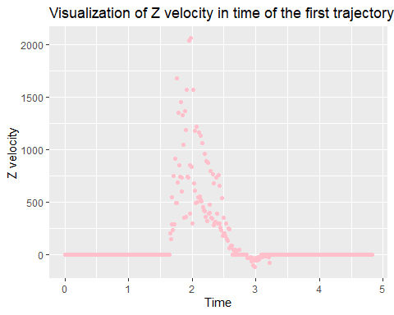

## applying butterworth filter  
  
# making cutoffs  
filter_cutoff <- .1 # setting the cutoff at 1/10-th of Nyquist frequency  
filter_order <- 2  
bw_f <- butter(filter_order, filter_cutoff, type ='low')   
  
  
# filter application  
data1$z_vel_f <- filtfilt(bw_f, data1$z_vel)  
   
  
## plotting filtered data vs raw data  
ggplot(data1, aes(time, z_vel)) +   
 geom_point(color = "red") +  
 geom_point(data = data1, aes(time,z_vel_f), color = "green") +  
 labs(title = "Visualization of filtered vs raw data",  
 subtitle = "Red = raw data Green = filtered data",  
 x = "Time",  
 y = "z")

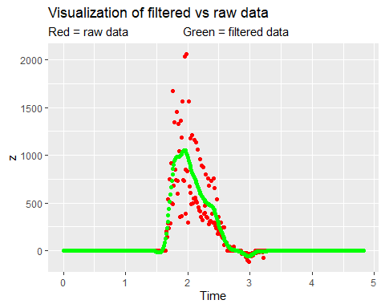

# we can see that the actual movement occurs only from aproixmately 1.6s to 3.4s, at least on te Z coordinate

It is a common practice to filter data movement because the this type of data is susceptible to artefacts, movement which are not related to a research question. For instance, fMRI is extremely sensitive to the slightest movements. Therefore accounting for subtle head movements, respiration is essential to obtain any meaningful results. Similarly, in the press-button experimental design, there is some limit how fast one can be at pressing a button. Hence, if the values are suspiciously low, one can extrapolate that a participant could accidentally double pressed a button, resulting in a confound. Setting a reasonable cut-off can prevent us from getting ridiculous results.

## References

Aglioti, S. M., Cesari, P., Romani, M., & Urgesi, C. (2008). Action anticipation and motor resonance in elite basketball players. *Nature Neuroscience*, *11*(9), 1109–1116. <https://doi.org/10.1038/nn.2182>

Bridgeman, B., & Tseng, P. (2011). Embodied cognition and the perception-action link. *Physics of Life Reviews*, *8*(1), 73–85. <https://doi.org/10.1016/j.plrev.2011.01.002>

Butler, A. J., & James, K. H. (2013). Active Learning of Novel Sound-producing Objects: Motor Reactivation and Enhancement of Visuo-motor Connectivity. *Journal of Cognitive Neuroscience*, *25*(2), 203–218. <https://doi.org/10.1162/jocn_a_00284>

Flanagan, J. R., & Wing, A. M. (1997). The Role of Internal Models in Motion Planning and Control: Evidence from Grip Force Adjustments during Movements of Hand-Held Loads. *Journal of Neuroscience*, *17*(4), 1519–1528. <https://doi.org/10.1523/JNEUROSCI.17-04-01519.1997>

Freeman, J. B. (2018). Doing Psychological Science by Hand. *Current Directions in Psychological Science*, *27*(5), 315–323. <https://doi.org/10.1177/0963721417746793>

Halász, V., & Cunnington, R. (2012). Unconscious Effects of Action on Perception. *Brain Sciences*, *2*(2), 130–146. <https://doi.org/10.3390/brainsci2020130>

Hommel, B. (2019). Theory of Event Coding (TEC) V2.0: Representing and controlling perception and action. *Attention, Perception, & Psychophysics*, *81*(7), 2139–2154. <https://doi.org/10.3758/s13414-019-01779-4>

Hommel, B., Brown, S. B. R. E., & Nattkemper, D. (2016). Perception and Action. In B. Hommel, S. B. R. E. Brown, & D. Nattkemper (Eds.), *Human Action Control: From Intentions to Movements* (pp. 75–107). Springer International Publishing. <https://doi.org/10.1007/978-3-319-09244-7_4>

Hommel, B., Müsseler, J., Aschersleben, G., & Prinz, W. (2001). The Theory of Event Coding (TEC): A framework for perception and action planning. *Behavioral and Brain Sciences*, *24*(5), 849–878. <https://doi.org/10.1017/S0140525X01000103>

Kieslich, P. J., Henninger, F., Wulff, D. U., haslbeck, jonas, & Schulte-Mecklenbeck, M. (2018). *Mouse-tracking: A practical guide to implementation and analysis* [Preprint]. PsyArXiv. <https://doi.org/10.31234/osf.io/zuvqa>

Massaro, D. W. (1990). An Information-Processing Analysis of Perception and Action. In O. Neumann & W. Prinz (Eds.), *Relationships Between Perception and Action: Current Approaches* (pp. 133–166). Springer. <https://doi.org/10.1007/978-3-642-75348-0_6>

Oyekoya, O., & Stentiford, F. W. M. (2005). A performance comparison of eye tracking and mouse interfaces in a target image identification task. *2nd European Workshop on the Integration of Knowledge, Semantics and Digital Media Technology (EWIMT 2005)*, 139–144. <https://doi.org/10.1049/ic.2005.0723>

Prinz, W. (1997). Perception and Action Planning. *European Journal of Cognitive Psychology*, *9*(2), 129–154. <https://doi.org/10.1080/713752551>

Spivey, M. (2007). *The continuity of mind*. Oxford University Press.